Shape of dataset: (7043, 21)

Column names:

['customerID', 'gender', 'SeniorCitizen', 'Partner', 'Dependents', 'tenure', 'PhoneService', 'MultipleLines', 'InternetService', 'OnlineSecurity', 'OnlineBackup', 'DeviceProtection', 'TechSupport', 'StreamingTV', 'StreamingMovies', 'Contract', 'PaperlessBilling', 'PaymentMethod', 'MonthlyCharges', 'TotalCharges', 'Churn']

Data types:

customerID object

gender object

SeniorCitizen int64

Partner object

Dependents object

tenure int64

PhoneService object

MultipleLines object

InternetService object

OnlineSecurity object

OnlineBackup object

DeviceProtection object

TechSupport object

StreamingTV object

StreamingMovies object

Contract object

PaperlessBilling object

PaymentMethod object

MonthlyCharges float64

...

3 Bank transfer (automatic) 42.30 1840.75 No

4 Electronic check 70.70 151.65 Yes

print(churn['TotalCharges'].loc[churn['TotalCharges'] == ' '].value_counts())

TotalCharges

11

Name: count, dtype: int64  
  
SeniorCitizen tenure MonthlyCharges TotalCharges

count 7032.000000 7032.000000 7032.000000 7032.000000

mean 0.162400 32.421786 64.798208 2283.300441

std 0.368844 24.545260 30.085974 2266.771362

min 0.000000 1.000000 18.250000 18.800000

25% 0.000000 9.000000 35.587500 401.450000

50% 0.000000 29.000000 70.350000 1397.475000

75% 0.000000 55.000000 89.862500 3794.737500

max 1.000000 72.000000 118.750000 8684.800000

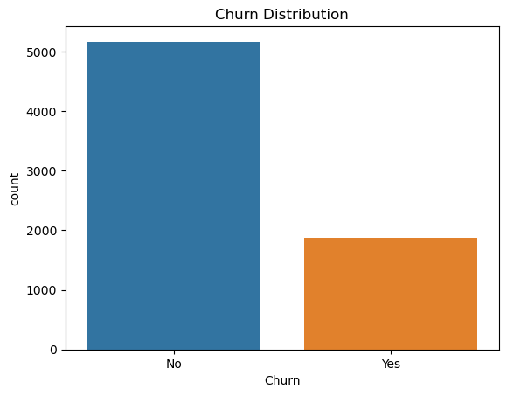

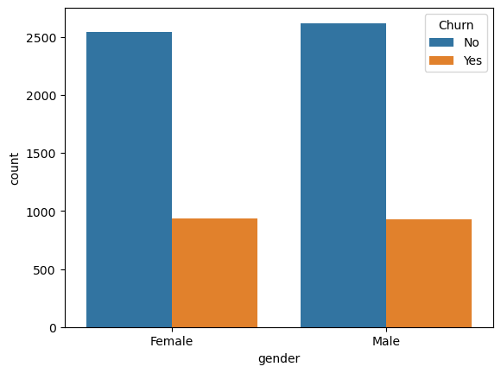

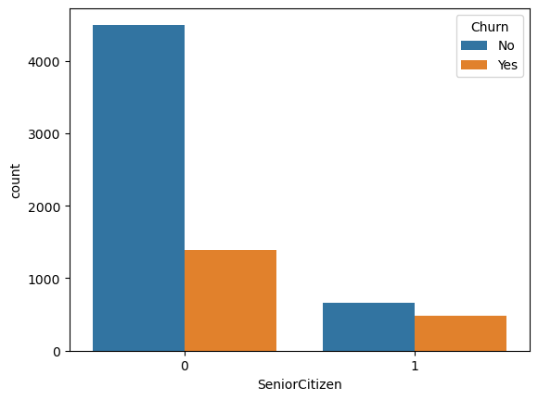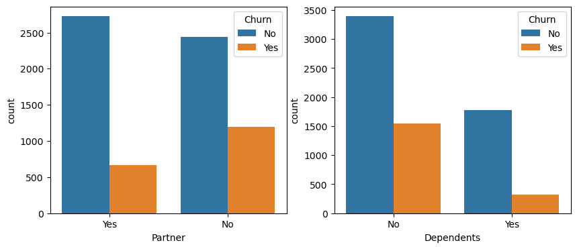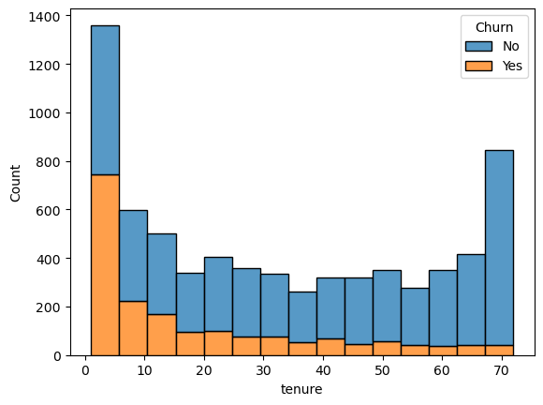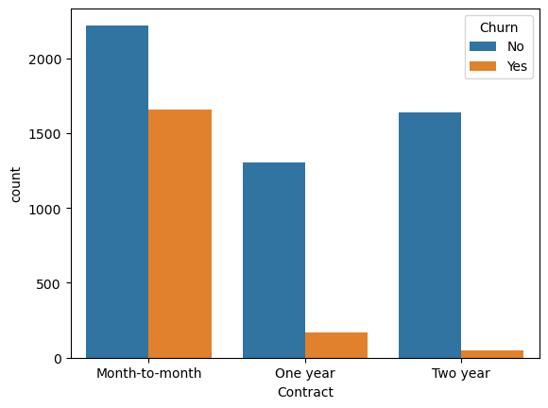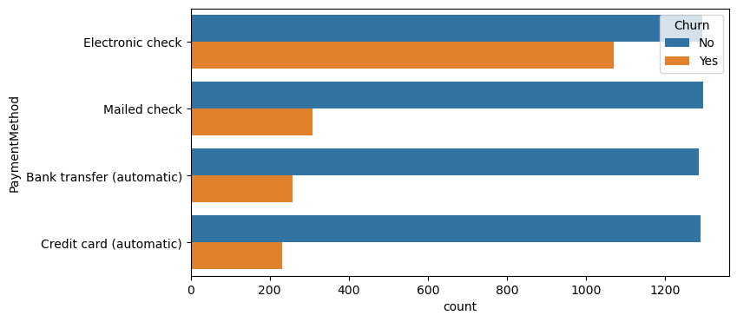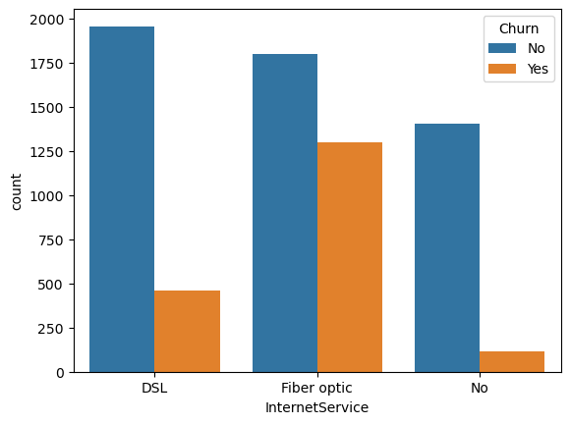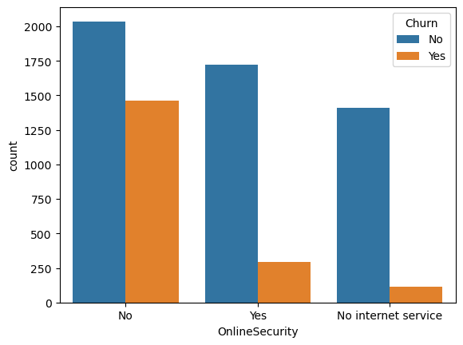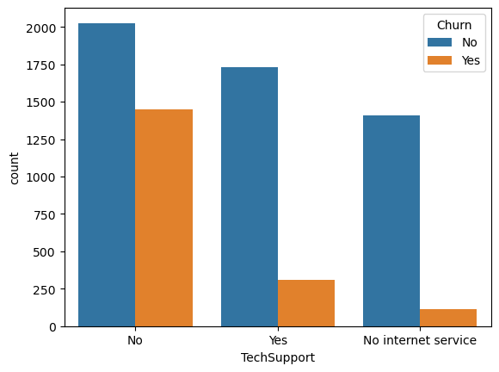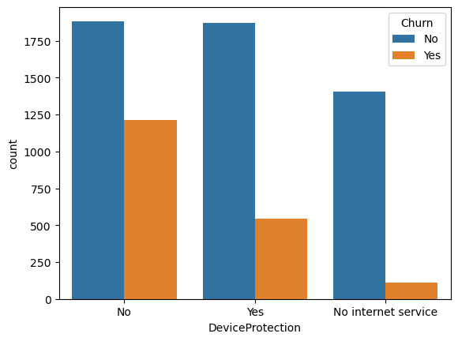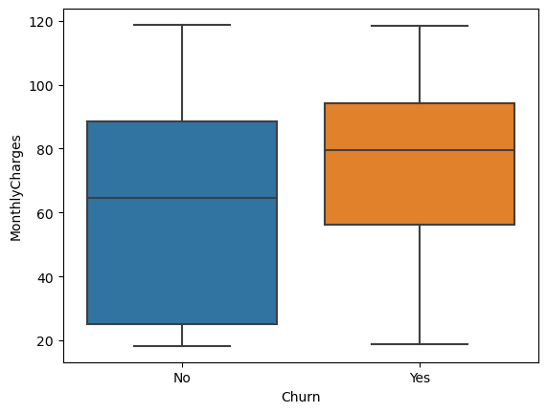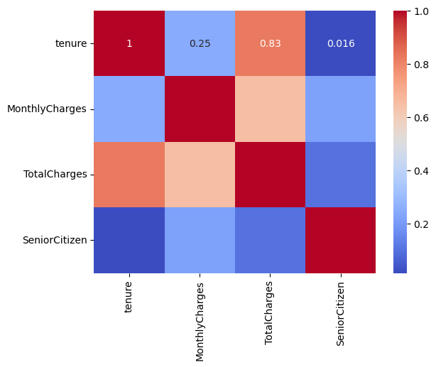Churn_flag 1.000000

InternetService_Fiber optic 0.307463

PaymentMethod_Electronic check 0.301455

MonthlyCharges 0.192858

PaperlessBilling_Yes 0.191454

SeniorCitizen 0.150541

StreamingTV_Yes 0.063254

StreamingMovies_Yes 0.060860

MultipleLines_Yes 0.040033

PhoneService_Yes 0.011691

gender_Male -0.008545

MultipleLines_No phone service -0.011691

DeviceProtection_Yes -0.066193

OnlineBackup_Yes -0.082307

PaymentMethod_Mailed check -0.090773

PaymentMethod_Credit card (automatic) -0.134687

Partner_Yes -0.149982

Dependents_Yes -0.163128

TechSupport_Yes -0.164716

OnlineSecurity_Yes -0.171270

Contract_One year -0.178225

TotalCharges -0.199484

DeviceProtection_No internet service -0.227578

OnlineSecurity_No internet service -0.227578

TechSupport_No internet service -0.227578

...

InternetService_No -0.227578

StreamingMovies_No internet service -0.227578

OnlineBackup_No internet service -0.227578

Contract_Two year -0.301552

Name: Churn_flag, dtype: float64

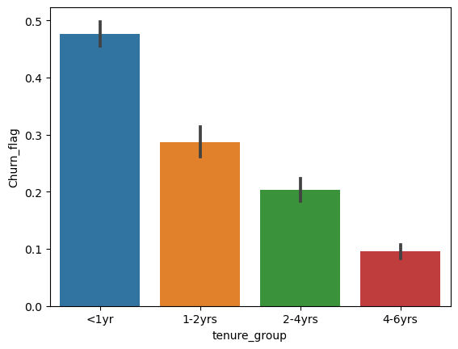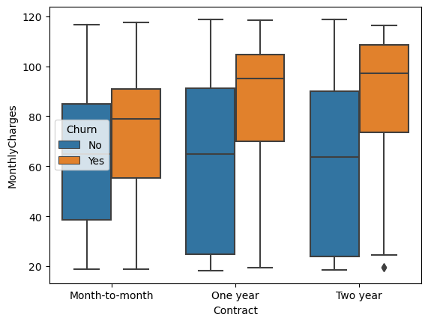InternetService:

InternetService

Fiber optic 0.418928

DSL 0.189983

No 0.074342

Name: Churn_flag, dtype: float64

OnlineSecurity:

OnlineSecurity

No 0.417787

Yes 0.146402

No internet service 0.074342

Name: Churn_flag, dtype: float64

OnlineBackup:

OnlineBackup

No 0.399417

Yes 0.215670

No internet service 0.074342

Name: Churn_flag, dtype: float64

TechSupport:

TechSupport

No 0.416475

Yes 0.151961

No internet service 0.074342

Name: Churn_flag, dtype: float64aymentMethod

Electronic check 0.452854

Mailed check 0.192020

Bank transfer (automatic) 0.167315

Credit card (automatic) 0.152531

Name: Churn_flag, dtype: float64

Partner Dependents

No No 0.342378

Yes 0.214485

Yes No 0.254083

Yes 0.143103

Name: Churn_flag, dtype: float64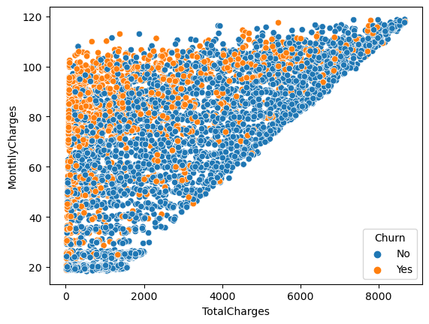

| **Contract** | **Month-to-month** | **One year** | **Two year** |
| --- | --- | --- | --- |
| **InternetService** |  |  |  |
| DSL | 0.506209 | 0.235927 | 0.257864 |
| Fiber optic | 0.687339 | 0.174096 | 0.138566 |
| No | 0.344737 | 0.238816 | 0.416447 |
| All | 0.551052 | 0.209329 | 0.239619 |

TotalCharges 0.185866

tenure 0.175922

MonthlyCharges 0.173959

InternetService_Fiber optic 0.040179

PaymentMethod_Electronic check 0.034098

Contract_Two year 0.029941

gender_Male 0.027262

OnlineSecurity_Yes 0.026201

PaperlessBilling_Yes 0.025882

TechSupport_Yes 0.025109

dtype: float64